# WAA Fall Baseball Bat Specifications 2025

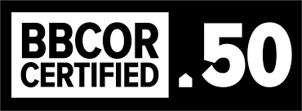

**1st-8th Grade: USA**

Bats up to 2 5/8” diameter “stamped” USA Baseball of any drop weight except drop 3 are permitted.

Non-USA stamped bats up to 2 ¼” in diameter are permitted.

**NO USSSA stamped bats are allowed**.

All wood bats are permitted.

All other bats not meeting the above descriptions are prohibited.

# High School: BBCOR

Bats up to 2 5/8” diameter and no longer than 36 inches in length are allowed.

Non BBCOR bats are allowed.

Bats cannot weigh, numerically, more than three ounces less than the length of the bat (e.g. a 33- inch-long bat cannot be less than 30 ounces).

All wood bats are permitted.

All other bats not meeting the above descriptions are prohibited.